**Medicinal Plants**

**Introduction of medicinal plants**

Medicinal plants, also called medicinal herbs, have been discovered and used in traditional medicine practices since prehistoric times. Plants synthesise hundreds of chemical compounds for functions including defense against insects, fungi, diseases, and herbivorous mammals. Numerous phytochemicals with potential or established biological activity have been identified. However, since a single plant contains widely diverse phytochemicals, the effects of using a whole plant as medicine are uncertain.

Further, the phytochemical content and pharmacological actions, if any, of many plants having medicinal potential remain unassessed by rigorous scientific research to define efficacy and safety. Medicinal plants are widely used in non-industrialized societies, mainly because they are readily available and cheaper than modern medicines.

Medicinal plants may provide three main kinds of benefit: health benefits to the people who consume them as medicines; financial benefits to people who harvest, process, and distribute them for sale; and society-wide benefits, such as job opportunities, taxation income, and a healthier labor force. However, development of plants or extracts having potential medicinal uses is blunted by weak scientific evidence, poor practices in the process of drug development, and insufficient financing.

**List of medicinal plants**

* **Tulsi Plant**

**Tulsi Medicinal Uses & Benefits**

Indian mythology attaches a great significance to Basil by recognizing it as a holy herb. Perhaps, such significance comes from the actual health applications of the herb. Its use is recommended as a first aid in the treatment of respiratory, digestive and skin diseases. Apart from these common ailments, Ayurveda also recognizes its use for the diseases ranging up to tumerous growths. Experimental studies identify it to be a highly promising immunomodulator, cytoprotective and anticancer agent.

Following are the benefits 5 & uses of Tulsi plant or Holy Basil/Ocimum Sanctum.

### Anti-aging

Vitamin C and A, phytonutrients, in Holy Basil are great antioxidants and protect the skin from almost all the damages caused by free radicals.

### Treats Kidney Stones

Tulsi acts a mild diuretic & detoxifying agent which helps in lowering the uric acid levels in the body. Acetic acid present in holy basil helps in the breakdown of the stones.

### Relieves Headaches

Tulsi is a natural headache reliever which can also relieve migraine pain.

### Relives Fever

Tulsi is an age-old ingredient for treating fever. It is one of the prime ingredients in the formulation of various ayurvedic medicines & home remedies.

### Eye Health

Tulsi's anti-inflammatory properties help promote eye health by preventing viral, bacterial and fungal infections. It also soothes eye inflammation and reduces stress.

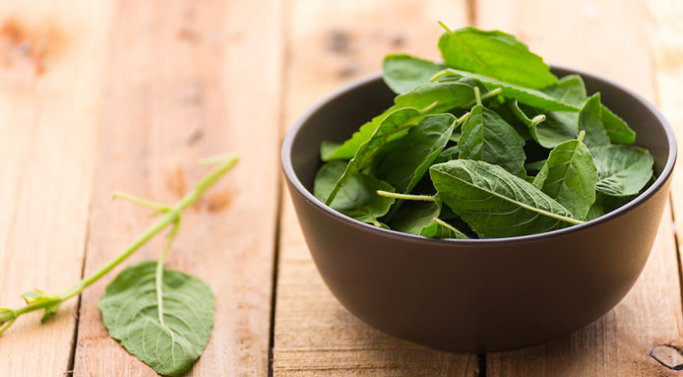

* **Mint Plant**

Mint plants grow in moist and humid soil with warm temperatures. Mint leaves are used to garnish several home cooked dishes and especially mint chutney is very popular among Indians. Mint is an extraordinary bearer of Vitamin A and iron. Additionally manganese and folate are also present abundantly in Mint. It improves bowel movement, brain function and digestion. Mint is also an easy fix for awful breath and cold.

Following are the benefits 5 & uses of Mint plant.

### Allergies

### Mint plants contain an antioxidant and anti-inflammatory agent called rosmarinic acid.

1. **Treats Asthma**

Consumption of mint has also been linked with bringing in soothing effect for asthmatic patients. Mint is loaded with anti-inflammatory properties. It is a good relaxant and relieves congestion

### Soothing common cold symptoms

Mint contains menthol which help to break up phlegm and mucus, making it easier to expel.Applying menthol ointments or vapor rubs may be a safe and effective treatment for children who have a common cold.

1. **Improves Brain Power**

Mint could also rev up your brain power. According to various studies, consuming mint may up alertness, retention, and cognitive functions.

## Diet

Mint leaves are a tender herb with gentle stems. It is best to add them raw or at the end of the cooking process. This helps them maintain their delicate flavor and texture.

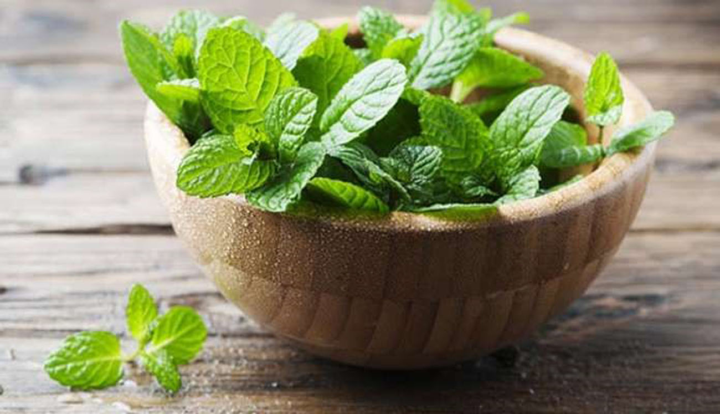

* **Aloe Vera Plant**

Aloe vera is a rich source of antioxidants and vitamins that may help protect your skin. The important compounds in aloe vera have also been shown to neutralize the effects of ultraviolet (UV) radiation, repair your skin from existing UV damage, and help prevent fine lines and wrinkles.

Following are the benefits 5 & uses of Mint plant.

1. **It has antioxidant and antibacterial properties**

## Antioxidants are important for health. It is known for its antibacterial, antiviral, and antiseptic properties. This is part of why it may help heal wounds and treat skin problems.

## It accelerates wound healing

## Aloe vera is a topical medication for wound. Experimental studies found that aloe vera could reduce the healing time of burns by around 9 days compared with conventional medication. It also helped to prevent redness, itching, and infections.

## It helps treat canker sores

## Many people experience mouth ulcers or canker sores so the aloe vera treatment can accelerate the healing of mouth ulcers

## It reduces constipation

## Aloe vera may also help treat constipation. The key compound responsible for this effect is called aloin, or barbaloin, which has well-established laxative effects.

## It may improve skin and prevent wrinkles

## Aloe vera could help the skin retain moisture and improve skin integrity, which could benefit dry skin conditions.

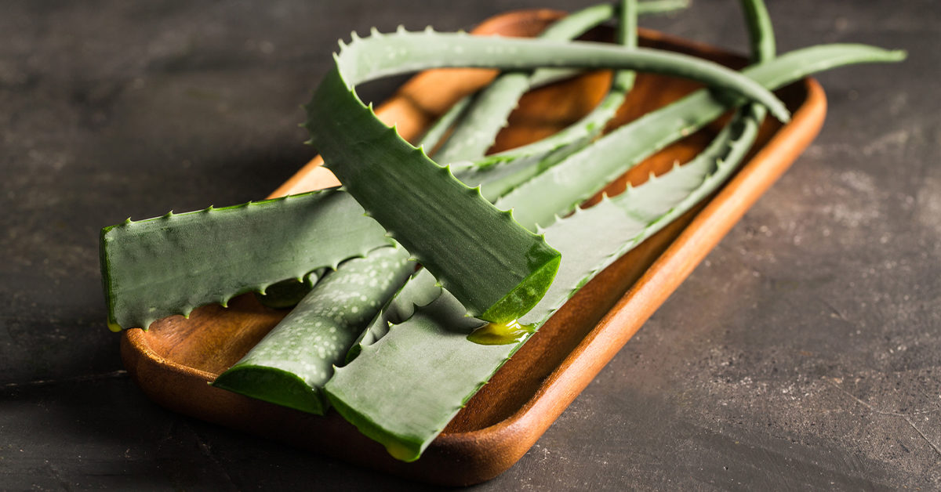

* **Ajwain Plant**

Ajwain- one of the important Indian herbs, that uplifts the taste of any Indian dish has to be this. Used in various forms and ways, Ajwain is one of the useful herbs. Every part of ajwain plant is used to make varied medicines and syrups. Having a very strong smell, Ajwain is called Ugargandha in Sanskrit, which means strongly scented. Ajwain leaf has a lot of uses and is known to be the instant reliever of a stomach ache.

Following are the benefits 5 & uses of Mint plant.

## Ajwain cures Kidney Stones

It is recommended to the people with kidney stones to have ajwain seeds, honey, and vinegar for ten days. This will help the stones meltdown and will help the person to get relieved with their kidney stones.

## Ajwain cures Asthma

For all those, who have asthma, Ajwain can act as a boon. Inhaling the smoke of Ajwain acts as a bronchodilator and brings ease to the breathing patterns. If the smoke cure seems a little scary to you, then make a paste of Ajwain and jaggery, and have it twice a day, this will help you in asthma treatment.

## Ajwain cures a Cold

For those who have a chronic or recurring cold, it is advised to have fried seeds of Ajwain in the dose of two grams, for about fifteen to twenty days. Also, apart from using ajwain leaf for cough, inhaling these seeds may bring relief from headaches, migraine, and even cough.

## Ajwain cures Diabetes

Recommended by the experts and doctors, the intake of one tablespoon of Ajwain along with four tablespoons of Bael leaves juice can be beneficial. Have this juice twice or thrice a day that will affect polyuria funds in Diabetics.

## Ajwain Helps in Weight Loss

Ajwain is a great appetizer and helps in fastening the bowel moment of laxative components. This helps in weight loss; in fact, regular intake of Ajwain can help you in maintaining obesity as well.

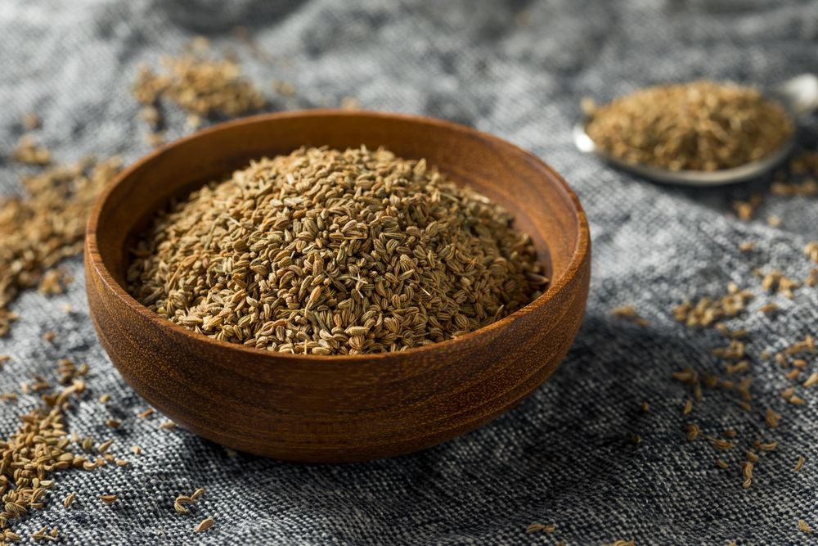

* **Curry Leaves**

In Ayurvedic medicine, curry leaves are believed to have several medicinal properties. They are considered to have anti-diabetic, antioxidant, antimicrobial, anti-inflammatory, anti-carcinogenic, and hepatoprotective (capability to protect the liver from damage) properties.

### ****Powerful Antioxidant:****

Curry leaves are rich in plant compounds which are powerful antioxidants. These compounds keep us healthy and protect us from numerous diseases.

### ****May Reduce the Risk of Cancer:****

Curry leaves have anti-mutagenic potential. They protect our body from different types of cancers.Flavonoids in Curry leaves act as anti-cancer agents. They are effective in inhibiting the growth of breast cancer cells.Curry leaves also protect the body from colon cancers. Curry leaves are also beneficial in protecting our body from cervical cancer.

### ****Reduces Risk of Heart Diseases:****

Curry leaves protect our heart by preventing oxidative damage. Consumption of Curry leaves also decreases the cholesterol levels. It also reduces the level of triglycerides. Reduction in risk factors thus helps in protecting us from heart diseases.

### ****Helpful for Diabetics:****

Consumption of Curry leaves helps in the management of diabetes and its related complications. Curry leaves were found to be highly effective in reducing the blood glucose levels.

### ****Analgesic:****

Curry leaves were found to be useful in relieving pain and used traditionally as an analgesic (pain reliever).

